**Preguntas de revisión**

* Preguntas en azul.
* Respuestas en verde.

1. In Java, methods must include all the following except:
2. a declaration
3. a call to another method
4. curly braces
5. a body
6. All method declarations contain:
7. the keyword static
8. one or more explicitly named access specifiers.
9. arguments
10. parentheses
11. A public static method named computeSum() is located in classA. To call the method from within classB, use the statement:
12. computeSum(classB);
13. classB(computeSum());
14. classA.computeSum();
15. You cannot call computeSum() from within classB.
16. Which of the following method declarations is correct for a static method named displayFacts() if the method receives an int argument?
17. public static int displayFacts()
18. public void displayFacts(int data)
19. public static void displayFacts(int data)
20. Two of these are correct.
21. The method with the declaration public static int aMethod(double d) has a method type of:
22. static
23. int
24. double
25. You cannot determine the method type.
26. Which of the following is a correct call to a method declared as public static void aMethod(char code)?
27. void aMethod();
28. void aMethod(‘V’);
29. aMethod(char ‘M’);
30. aMethod(‘Q’);
31. A method is declared as public static void showResults(double d, int i).

Which of the following is a correct method call?

1. showResults(double d, int i);
2. showResults(12.2, 67);
3. showResults(4, 99.7);
4. Two of these are correct.
5. The method with the declaration public static char procedure(double d) has a method type of:
6. public
7. static
8. char
9. double
10. The method public static boolean testValue(int response) returns:
11. a boolean value
12. an int value
13. no value
14. You cannot determine what is returned.
15. Which of the following could be the last legally coded line of a method declared as public static int getVal(double sum)?
16. return;
17. return 77;
18. return 2.3;
19. Any of these could be the last coded line of the method.
20. The nonstatic data components of a class often are referred to as the of that class:
21. access types
22. instance variables
23. methods
24. objects
25. Objects contain methods and data items, which are also known as:
26. fields
27. functions
28. themes
29. instances
30. You send messages or information to an object through its:
31. fields
32. methods
33. classes
34. type
35. A program or class that instantiates objects of another prewritten class is a(n):
36. class client
37. superclass
38. object
39. patron
40. The body of a class is always written:
41. in a single line, as the first statement in a class
42. within parentheses
43. between curly braces
44. as a method call
45. Most class data fields are:
46. private
47. public
48. static
49. final
50. The concept of allowing a class’s private data to be changed only by a class’s own methods is known as:
51. structured logic
52. object orientation
53. information hiding
54. data masking
55. Suppose you declare an object as Book thisBook; Before you store data in thisBook, you:
56. also must explicitly allocate memory for it
57. need not explicitly allocate memory for it
58. must explicitly allocate memory for it only if it has a constructor
59. can declare it to use no memory
60. If a class is named Student, the class constructor name is:
61. any legal Java identifier
62. any legal Java identifier that begins with S
63. StudentConstructor
64. Student
65. If you use the automatically supplied default constructor when you create an object:
66. numeric fields are set to 0 (zero)
67. character fields are set to blank
68. Boolean fields are set to true
69. All of these are true

**Ejercicios de programación**

* Respuestas en verde.
* Enlaces a los archivos en azul.

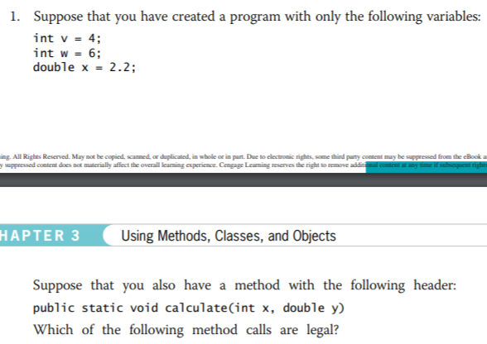

a. calculate(v, w);

b. calculate(v, x);

c. calculate(x, y);

d. calculate(18, x);

e. calculate(1.1, 2.2);

f. calculate(5, 7

a. obA.b = 12;

b. obA.c = 5;

c. obA.d = 23;

d. ClassA.b = 4;

e. ClassA.c = 33;

f. ClassA.d = 99;

Enlace al archivo: <https://github.com/logralahad/POO1_Capitulo3/tree/main/chapter3_Joyce/src/ejercicio3>

Enlace al archivo: <https://github.com/logralahad/POO1_Capitulo3/tree/main/chapter3_Joyce/src/ejercicio4>

Enlace al archivo: <https://github.com/logralahad/POO1_Capitulo3/tree/main/chapter3_Joyce/src/ejercicio5>

Enlace al archivo: <https://github.com/logralahad/POO1_Capitulo3/tree/main/chapter3_Joyce/src/ejercicio6>

Enlace al archivo: <https://github.com/logralahad/POO1_Capitulo3/tree/main/chapter3_Joyce/src/ejercicio7>

Enlace al archivo: <https://github.com/logralahad/POO1_Capitulo3/tree/main/chapter3_Joyce/src/ejercicio8>

Enlace al archivo: <https://github.com/logralahad/POO1_Capitulo3/tree/main/chapter3_Joyce/src/ejercicio9>

Enlace al archivo: <https://github.com/logralahad/POO1_Capitulo3/tree/main/chapter3_Joyce/src/ejercicio10>

Enlace al archivo: <https://github.com/logralahad/POO1_Capitulo3/tree/main/chapter3_Joyce/src/ejercicio11>

Enlace al archivo: <https://github.com/logralahad/POO1_Capitulo3/tree/main/chapter3_Joyce/src/ejercicio12>

Enlace al archivo: <https://github.com/logralahad/POO1_Capitulo3/tree/main/chapter3_Joyce/src/ejercicio13>

Enlace al archivo: <https://github.com/logralahad/POO1_Capitulo3/tree/main/chapter3_Joyce/src/ejercicio14>

**Game Zone**

* Enlaces a los archivos en azul.

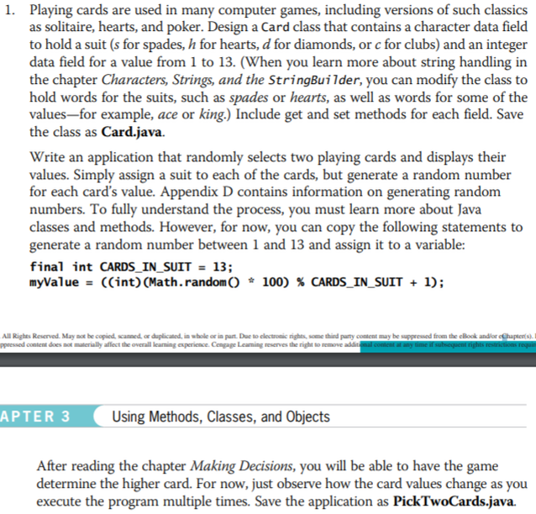





Enlace al archivo: <https://github.com/logralahad/POO1_Capitulo3/tree/main/chapter3_Joyce/src/gameZone1>

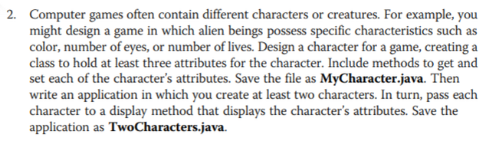

Enlace al archivo: <https://github.com/logralahad/POO1_Capitulo3/tree/main/chapter3_Joyce/src/gameZone2>

**Case Problems**

* Enlaces a los archivos en azul.

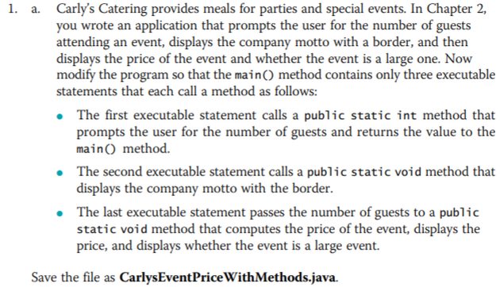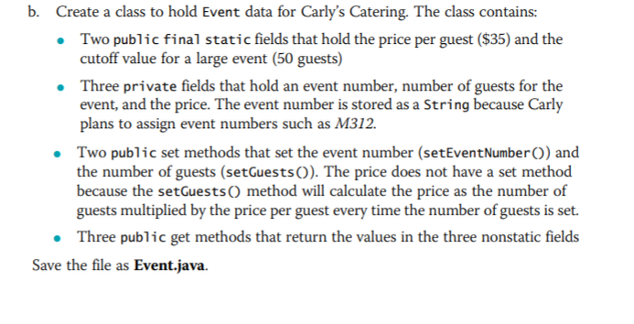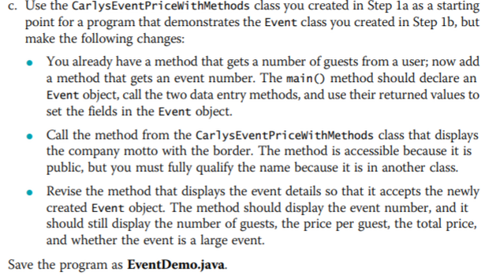

Enlace al archivo: <https://github.com/logralahad/POO1_Capitulo3/tree/main/chapter3_Joyce/src/caseProblem1>

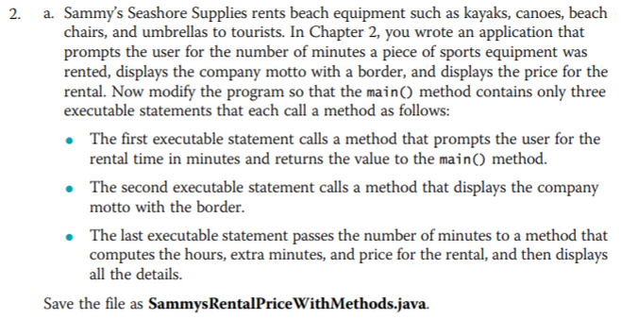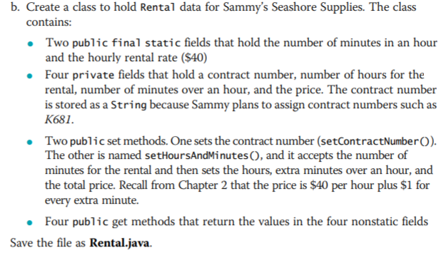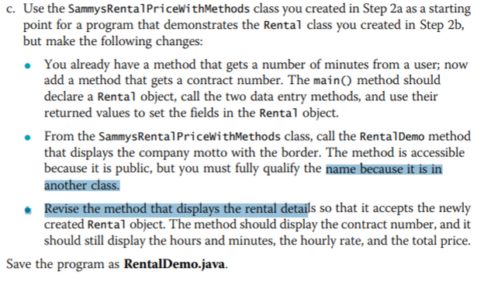

Enlace al archivo: <https://github.com/logralahad/POO1_Capitulo3/tree/main/chapter3_Joyce/src/caseProblem2>